- A.) Examine a scatterplot of the Distance from the Sun (y) versus Position Number (x). Does it look straight?
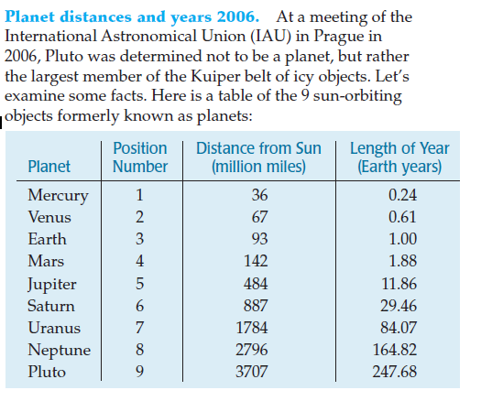

B.) Find the line of best fit for the data set. Sketch the residual plot. Is the line a good fit for the data set?

C.) Transform the data to make it more linear. Justify your choice of a transformation.

D.) Find the line of best fit for the transformed data. Record it here.

E.) Sketch the residual plot for the (transformed) linear model. Does the line fit the transformed data better than the original line fit the original data set?

F.) Starting with your linear model for the transformed data, perform a reverse transformation to arrive at your final, curved model. Show all steps! (Verify your answer in the calculator if possible.)

G.) Use your model (either one) to predict what Pluto’s distance from the sun should be based on its position. Would you agree with the International Astronomical Union that Pluto is not a planet? Explain.

- A.) Now examine a scatterplot of the Length of Year (y) versus Position Number (x). Does it look straight?

B.) Find the line of best fit for the data set. Sketch the residual plot. Is the line a good fit for the data set?

C.) Transform the data to make it more linear. Justify your choice of a transformation.

D.) Find the line of best fit for the transformed data. Record it here.

E.) Sketch the residual plot for the (transformed) linear model. Does the line fit the transformed data better than the original line fit the original data set?

F.) Starting with your linear model for the transformed data, perform a reverse transformation to arrive at your final, curved model. Show all steps! (Verify your answer in the calculator if possible.)

G.) Use your model (either one) to predict what Pluto’s year length should be based on its position. Does this support or refute the International Astronomical Union’s assertion that Pluto is not a planet? Explain.

