1. A.) Examine a scatterplot of the data set. What form is the relationship between x and y?
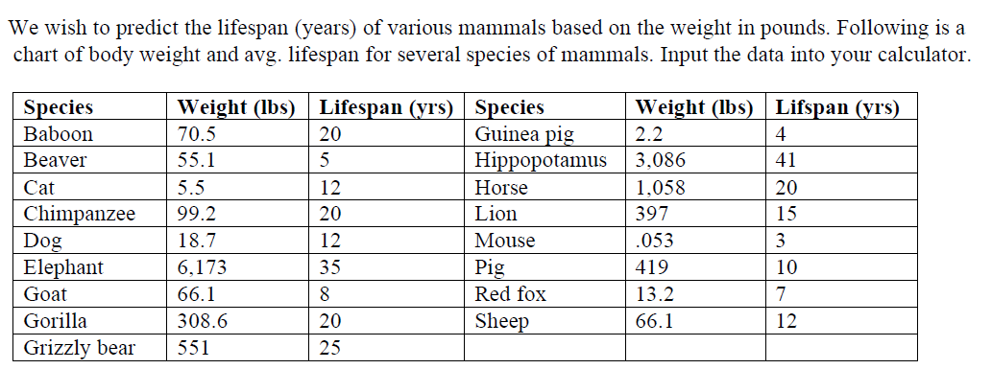

B.) Decide whether an exponential or power function would be a better fit for the data set. Justify your answer.

C.) Transform the data to make it more linear. Find the line of best fit for the transformed data. Record it here.

D.) Sketch the residual plot for the linear model below. Does the linear model fit the transformed model well?

E.) Interpret the slope of the linear model in the context of the problem.

F.) Interpret the y-intercept of the linear model in the context of the problem.

G.) Use the linear model to predict the lifespan of a human that weighs 150 pounds.

H.) Starting with your linear model for the transformed data, perform a reverse transformation to arrive at your final, curved model. Show all steps! (Verify your answer in the calculator if possible.)

I.) Predict the lifespan of a dog that weighs 85 pounds.
2. A.) Examine a scatterplot of the data set. What form is the relationship between x and y?
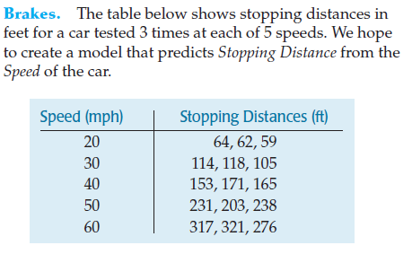

B.) Decide whether an exponential or power function would be a better fit for the data set. Justify your answer.

C.) Transform the data to make it more linear. Find the line of best fit for the transformed data. Record it here.

D.) Sketch the residual plot for the linear model below. Does the linear model fit the transformed model well?

E.) Interpret the slope of the linear model in the context of the problem.

F.) Interpret the y-intercept of the linear model in the context of the problem.

G.) Use the linear model to predict the stopping distance of a car traveling 70mph.

H.) Starting with your linear model for the transformed data, perform a reverse transformation to arrive at your final, curved model. Show all steps! (Verify your answer in the calculator if possible.)

I.) Predict the stopping distance of a car traveling 90mph.

