Sinner Station (GSP Fil)
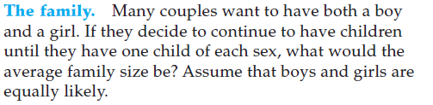
Identify the events & their probabilities:

State the variables:

State what you want to conclude about:

Write a conclusion statement.

 | Frequency | Relative Frequency
Boy
Girl
Totals

Dice Station (need two dice)

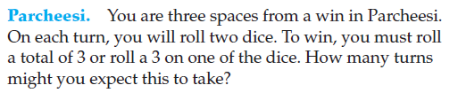
Identify the events & their probabilities:

State the variables:

State what you want to conclude about:

Write a conclusion statement.

Die 1 | Frequency | Die 2 | Frequency
1 |  | 1
2 |  | 2
3 |  | 3
4 |  | 4
5 |  | 5
6 |  | 6

Cards (need 20 cards = 14 black numbers & 6 red face cards … use opposite to make a second group)

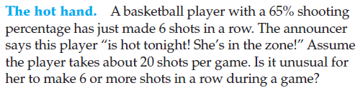
Identify the events & their probabilities:

State the variables:

State what you want to conclude about:

Write a conclusion statement.
What is the percentage before making 6 in a row?
_________________
Frequency (outcome count)
Did not make 6 in a row
(number card before all face cards
Made 6 in a row

Spinner Station #2 (gsp file – “Lucky Guessing”

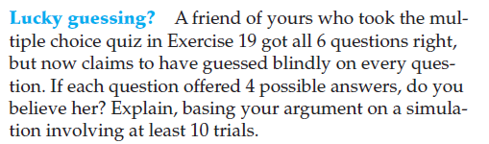
Make Your Answer Key:
Question 1 =
Question 2 =
Question 3 =
Question 4 =
Question 5 =
Question 7 =
Question 9 =
Question 10 =
Use the spinner to write down the outcome for each question / spin.
What did your simulation show?
Write an explanation including identifying the independent and dependent variables.

 | Frequency | Relative Frequency
A
B
C
D

Random Number Generator

4 Children Family
Matt Ryan’s passing completion percentage is 72%. Suppose he attempts 15 passes in a game. Use a random number generator to conduct 6 trials and record your results. Based on your results, what is the mean number of passes he will make in a game?
Use the following random number generator:
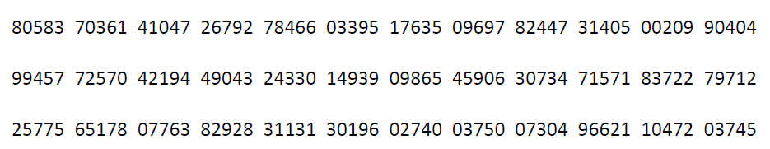

1) How did you conduct 6 trials using the same random number set?

2) Identify events & their probabilities

3) Assign numbers to events:

4) One trail equals …

3) List out your outcomes in a table?

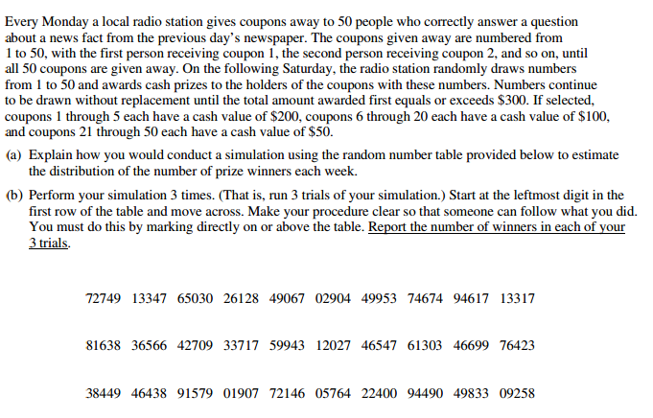
Free Response Question ( Due Friday )

